Student Software Solutions

Technical Design Documentation

eTendance

Table of Contents

Software Requirements 2

Database Model 4

Use Case Diagram 5

Software Architectural Diagram 5

Software Lexicon 6

Paper Prototypes 8

User Profiles 13

Task Analysis 14

Usability Test Outiline 15

Test Users 15

Test Script 15

General 15

Professor 15

Student 16

Usability Report 17

# Software Requirements

1. The software shall allow guests to create an account as either a student or a professor.

Explanation: In the users table, a user has usertype that can either have the value 's' for student, or 'p' for professor.

1. The software shall allow professors to create a new class.

Explanation: If a user is a professor, then their id will be linked to a class that they create, which will share the same id number. The classowners table is an associative entity that designates which professors teach which class, linking professorid to classid as primary keys. This means that the professor has claimed ownership of that particular class.

1. The software shall generate a unique link per class for use with student registration.

Explanation: The enrollmentcode of the classes table will serve as the link that the student users will use when registering for classes. The enrollmentcode is unique as to distinguish it from other classes.

1. The software shall allow professors to delete a class.

Explanation: Along with being able to create a class, a professor has the ability to remove the class, as well as the data associated with it, from the system. Students do not have the ability to remove an entire class from the system. This can only be done by professors who have ownership of that class as dictated by the classowners table.

1. The software shall allow professors to view attendance statistics for a class.

Explanation: A professor user has the ability to view an entry in the checkin table with the same user id as the professor and the same classid as a class that the user owns.

1. The software shall allow professors to manually edit attendance by day for a class.

Explanation: As the owner of a class, the professor has the ability to change the data in an entry in the checkins table that contains the classid of a class that is owned by the professor.

1. The software shall allow professors to generate a time-sensitive pin and QR code for use with student check-in.

Explanation: For a class that a professor owns, the professor can generate the code in checkincodes to represent the QR code or pin that will be used by student users to check in to class. The creationtime attribute will dictate the time-sensitivity of the code and the code will only work on the data specified by forclassday in the checkincodes table.

1. The software shall allow students to register for a class with the link provided by the professor.

Explanation: Using the link provided by the enrollmentcode in the classes table, the student will become enrolled in the class. The enrollment table will link the userid of the student to the classid of the class that they just registered for.

1. The software shall allow students to drop a class.

Explanation: To maintain referential integrity, when a student drops a class, the enrollment table will drop the relation that links the userid of the student and the classid of the class that they dropped.

1. The software shall allow students to view his/her attendance for a class.

Explanation: The student user may view their attendance record for any class that they are registered in as dictated by the enrollment table, where a student is linked to the classid of the classes they are enrolled in. However, they do not have the ability to edit their attendance, as they cannot be owners of classes.

1. The software shall allow students to check in for a class with the pin or QR code provided by the professor.

Explanation: Using the code attribute in checkincodes table, the student user will be able to enter the pin into their version of the software to mark themselves as present in the class for that particular day. The checkins table will then be updated with the userid of the student linked with the classid of the class they checked into, provided that the checkincodeid is the same as the code of the necessary relation in checkincodes.

# Database Model

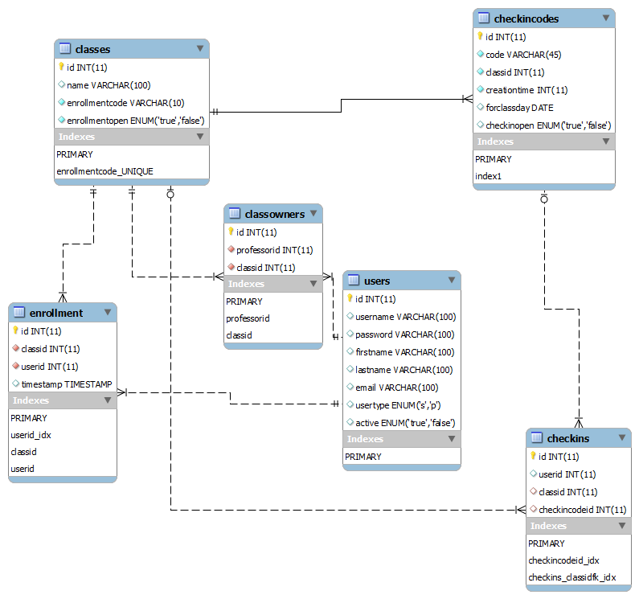

# Use Case Diagram

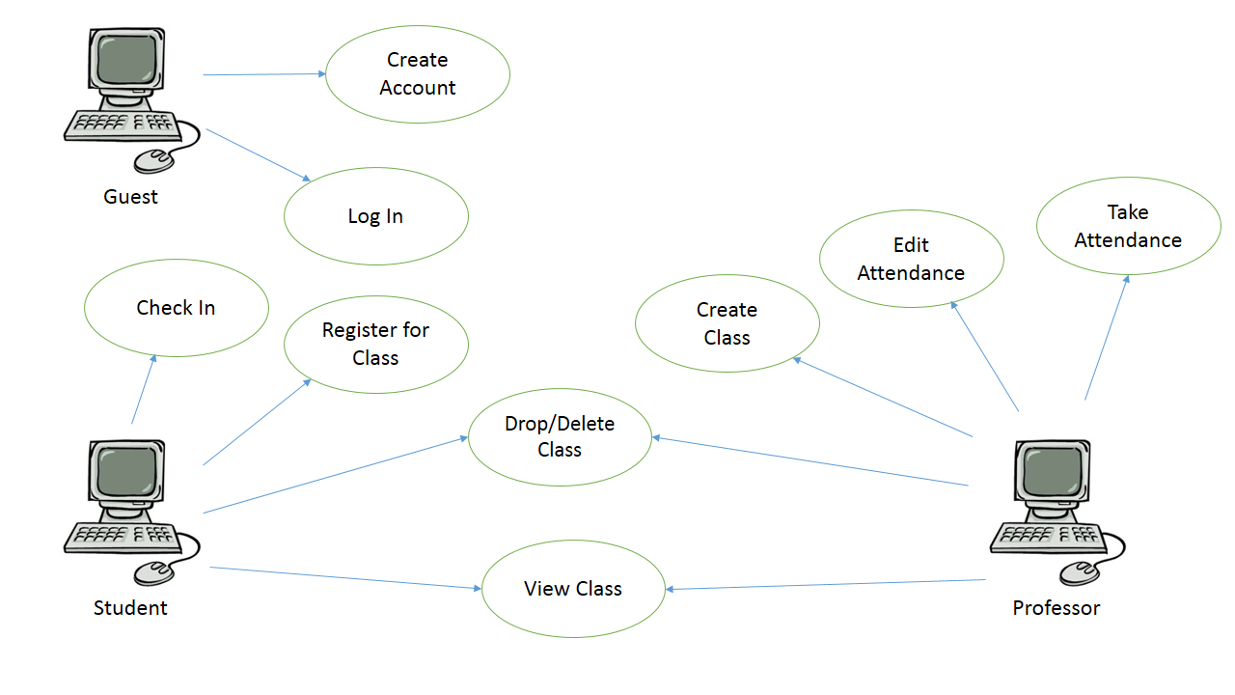

# Software Architectural Diagram

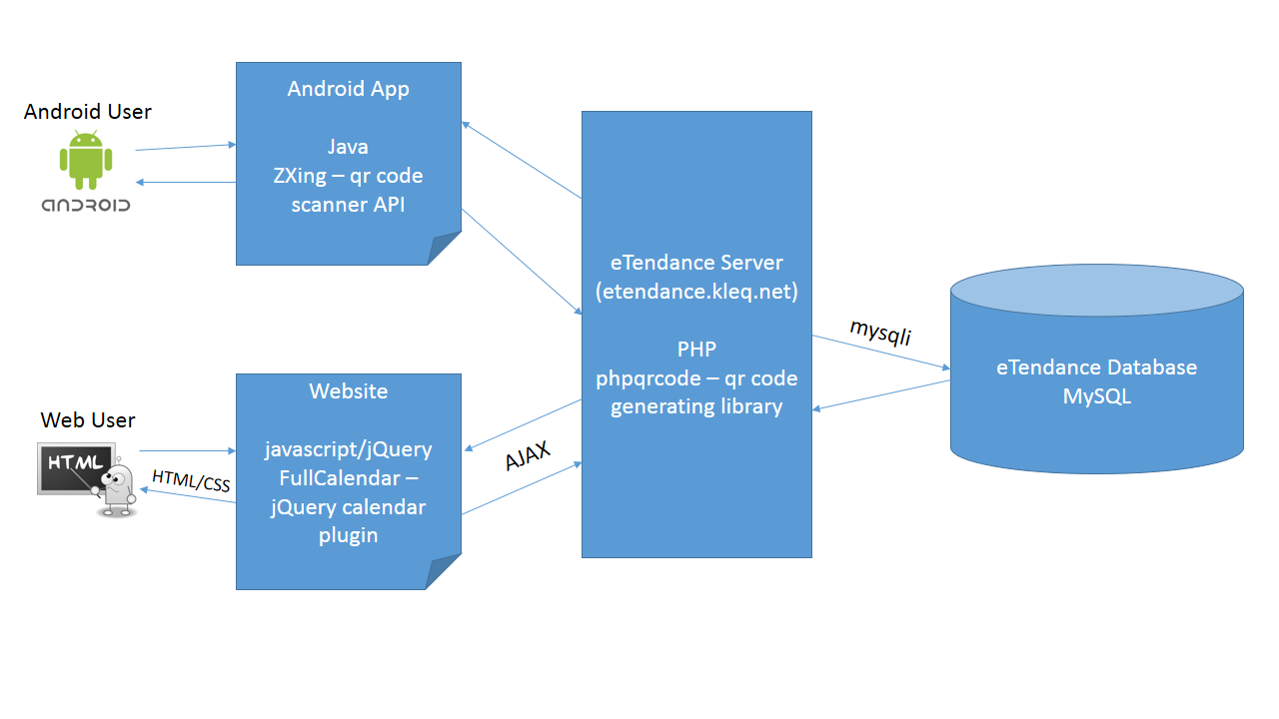

# Software Lexicon

**A**

Absent – a student does not check in for a class session

Add – a professor creates a new class, which generates a unique registration link to distribute to his/her students

Attendance – the professor generates an attendance pin

Attendance Pin – a time-sensitive (default 10 minutes) number that is generated by the professor and is unique to a class for a session, so that students can check in for that class session; comes in a string of digits and is also encoded into a QR code

**C**

Check In – a student verifies that he/she is present for a session of a class using the attendance pin; failure to do so results in the student being counted as absent for that session

Class – contains a roster of students and stores information on which students were present and absent on each day that attendance is taken over the course of that class’s term

**D**

Delete – a professor removes all attendance data about a class; registration link becomes invalid

Drop – a student removes himself/herself from a class’s roster

**E**

Edit – a professor manually marks one or more students as absent or present for a class session

**G**

Guest – a user who is not logged in

**I**

Invalid – when a class’s registration link no longer adds students to a roster after a class is deleted or an attendance pin no longer marks students as present after its time period is up

**P**

Present – a student checks in for a class session

Professor – a user that is logged into an account that can create and delete classes and take and edit attendance

**R**

Register – a student follows the registration link generated by a professor and is added to the roster for that class

Roster – the list of students that have registered for a class

**S**

Session – when the class meets and an attendance pin is generated, eTendance assumes that each class holds, at most, one meeting per day

Student – a user that is logged into an account that can register and check in for classes

**T**

Term – the period of time from when a professor creates a class to when he/she deletes that class

# Paper Prototypes

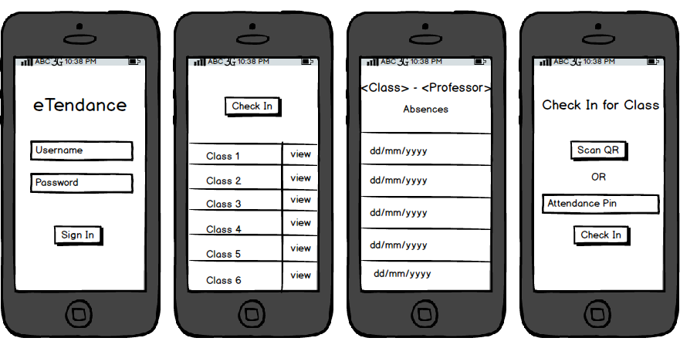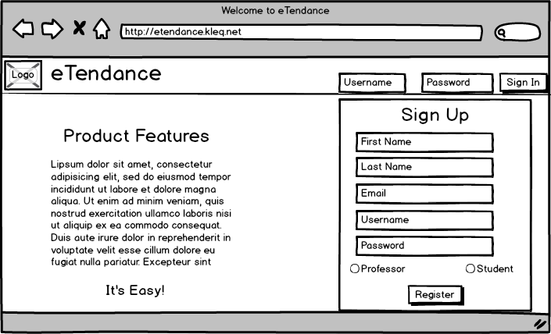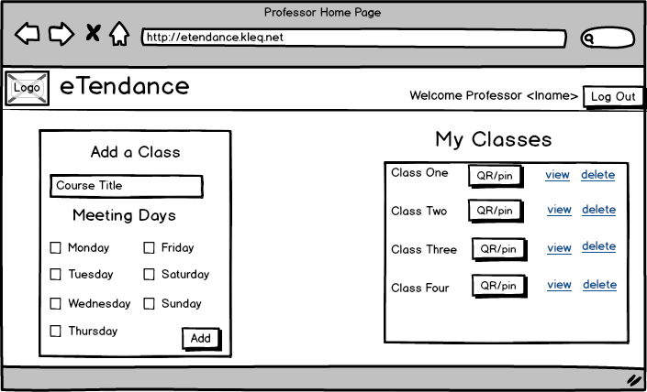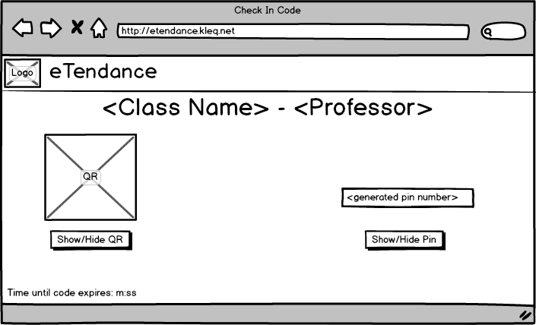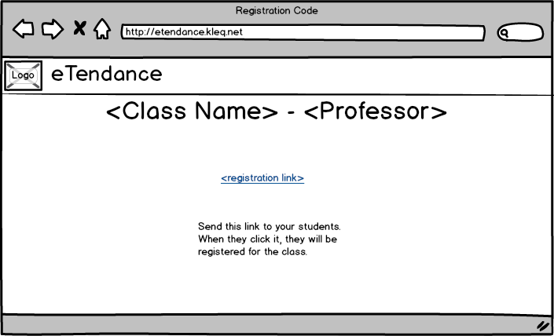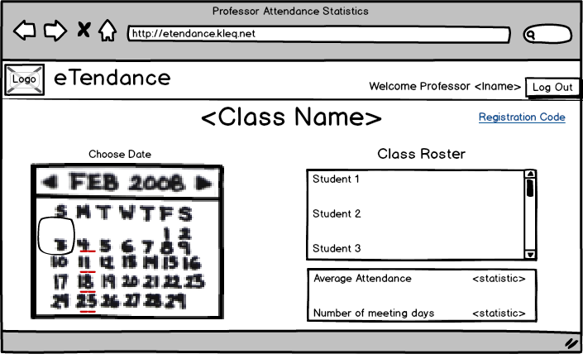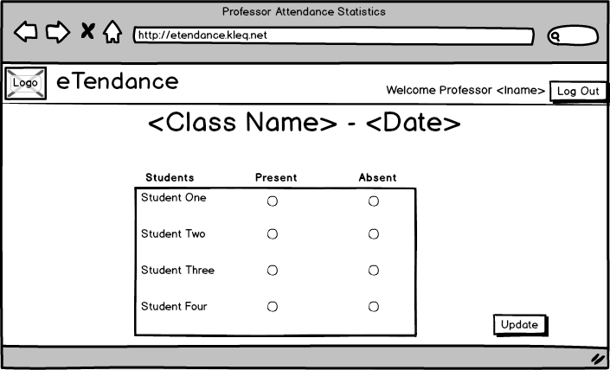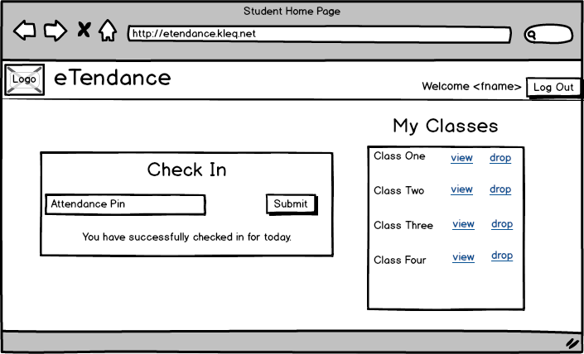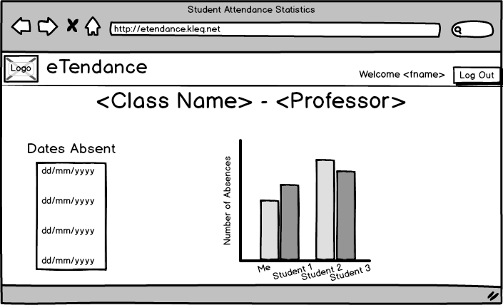

# User Profiles

Vince Matranga, student:

* age 21, engineering student with computer science major at SMU, no regular income
* computer use: all the time – phone use: often
* For the website, Vince was confused when he tried to come back to last page, and he suggested that add a back button on the website.
* He couldn’t go back to the pervious page on the Mobile app. Obviously, we are missing back button.

Michael Forrest, student:

* age 22, business student with marketing major at SMU, no regular income
* computer use: often – phone use: all the time
* He likes this application a lot.
* Confusing to get back to Student Home page.

Adriana Rocio Aceves, professor:

* age 54, Mathematics Professor at SMU, $50000/yr
* computer use: regular – phone use: regular
* In Professor Aceves’s classes, students take attendance every time, and she thinks this tool is very useful. Also, she wants to be the first user for this application.
* In her opinions, it’s makes professors easier if our also can add the attendance statistics for each student, so professors can calculate students’ grades easily.

# Task Analysis

Vince Matranga:

        Q: Have you ever heard of or used a product like eTendance before?

        A: I knew there were apps like this, but I’ve never used one.

        Q: Would you be more likely to use eTendance on your computer or your phone?

        A: Probably my computer.

        Q: What other information would you expect eTendance to display?

        A: eTendance can give students a chance to give professors some feedback.

Michael Forrest:

        Q: Have you ever heard of or used a product like eTendance before?

        A: No, but I’m not surprised something like this exists.

        Q: Would you be more likely to use eTendance on your computer or your phone?

        A: A bit of both.

        Q: What other information would you expect eTendance to dispaly?

        A: It seems all good.

Adriana Rocio Aceves:

        Q: Have you ever heard of or used a product like eTendance before?

        A: No.

        Q: Would you be more likely to use eTendance on your computer or your phone?

        A: My computer.

        Q: What other information would you expect eTendance to display?

A: it’s makes professors easier if our also can add the attendance statistics for each student, so professors can calculate students’ grades easily.

# Usability Test Outiline

## Test Users

Two professors: Chris Raley, Adriana Aceves

Two students: Vince Matranga, Michael Forrest

## Test Script

Test type: Think aloud testing – ask users to perform certain actions and listen to their thought process while performing them.

Actions user is asked to perform/observations to make in the process:

### General

Create an account.

* Is it clear where to sign up?
* Is it easy to differentiate between creating student and professor accounts?

Log in.

* Is it clear where to log in?
* Is it confusing that there is no difference for professor and student logins?

### Professor

Add a class.

* Is it clear how to add a class?
* Is it clear how to use the code/pin for registering students?.

Delete a class.

* Is it clear how to delete a class?

Generate attendance code.

* Is it clear how to generate an attendance code for a specific class?
* Is it clear how to use the code/pin generated?

View attendance statistics for a class.

* Is it clear how to view stats for a particular class?
* Is it clear what attendance statistics are represented?

View attendance for any given day for a class.

* Is it clear how to access a particular day’s attendance?

Edit attendance for a student for a given day.

* Is it clear how to access the attendance for a student on a given day?
* Is it clear how to edit the attendance once it is accessed?

### Student

Register for a class.

* Is it clear how to add a class using the pin/code?

Drop a class

* Is it clear how to drop a class?

Check-in for a class.

* Is it clear how to check-in using the pin/code?

View attendance statistics for a class.

* Is it clear how to view statistics for each class?
* Is it clear what attendance statistics are represented?

# Usability Report

Problems Found:

1. It was confusing to the user to have both a class registration pin and an attendance check in pin. It was also a confusing to the professor how to register students to a class after it was created.
   1. Type/Severity: Ease of use/minor problem, annoying
   2. Solution: Change the registration pin to a link and added instructions for the professor to send the link in an email. Also got rid of add class functionality from app.
2. The roster of students for a class should be available to view easily. Can only really be seen by going to a specific day’s attendance.
   1. Type/Severity: Missing functionality/annoying
   2. Solution: Add a class roster to the view page of each class.
3. Each student should have an attendance percentage available for the professor to view.
   1. Type/Severity: Missing functionality, bug
   2. Solution: Add attendance percentage next to each student’s name in the roster.
4. The student view of attendance should be more concise for students to get more information in less effort.
   1. Type/Severity: Missing functionality, ease of use/minor problem, annoying
   2. Solution: Change statistics to a chart to compare absences with the class and list the overall attendance percentage.
5. Not very clear how to return to home page after going to view statistics.
   1. Type/Severity: Ease of use/minor problem, annoying
   2. Solution: Make the user’s name, in the top bar of the webpage, the link back. It will show as a link, so it should stand out.
6. The calendar should highlight days when classes are usually scheduled, so professors should be able to input when their class meets.
   1. Type/Severity: Ease of use
   2. Solution: Add checkboxes to the Add Class form to allow professors to select class meeting days. Add highlighting to the calendar for those days.
7. The student’s check in should show whether it was successful or not so they know that it worked.
   1. Type/Severity: Ease of use/annoying
   2. Solution: Show Success/Failure message after student sends a check in attempt.
8. Confusing that deleting a class for the professors is also called Drop.
   1. Type/Severity: Ease of use
   2. Solution: Change wording to Delete to make more sense.
9. It would be more convenient if the two inputs for the Sign In form were placed next to the button.
   1. Type/Severity: Ease of use/annoying
   2. Solution: Move input boxes and get rid of the popup.
10. There doesn’t need to be a popup for confirming log out.
    1. Type/Severity: Ease of use/annoying
    2. Solution: Get rid of the popup.